
SIMATS ENGINEERING
Saveetha Institute of Medical and Technical Sciences

DEPARTMENT: B.TECH COMPUTER SCIENCE & BIO SCIENCE
COURSE NAME: SOFTWARE ENGINEERING (CSA1008)
CO1 ASSESSMENT TITLE AT2: Agile sprint planning and user story worrkshop
CASE STUDY TITLE: Case Study 24 – SDG 3: School Nutrition Monitoring System Government
STUDENT NAME: S.NISHITAA
REGISTER NUMBER:192471034
FACULTY NAME:Dr. K.C. SHARMILI

DATE OF SUBMISSION: 28/07/2026

INTRODUCTION

1.1 Background and Domain Context
Across developing and emerging economies, government-sponsored school meal initiatives play a pivotal role in promoting child welfare, reducing classroom hunger, and improving overall primary and secondary educational retention. Under the framework of Sustainable Development Goal 3 (SDG 3: Good Health and Well-Being) established by the United Nations, ensuring that children receive clean, safe, and balanced nutritional intake is a fundamental public health priority.
Historically, these school feeding programs have relied heavily on decentralized, paper-based administrative records. School principals, headmasters, and local kitchen staff manually maintain daily paper logs recording student attendance, raw ingredient purchases, menu plans, and daily meal distribution counts. While this manual system was functional in earlier decades, it has proven increasingly fragile, inefficient, and susceptible to severe operational challenges in the modern era.

1.2 Operational Challenges in Manual Nutrition Tracking
The traditional paper-bound approach creates major operational bottlenecks and transparency gaps across all administrative tiers:
- Inaccurate Attendance and Meal Tracking: Manual logbooks frequently exhibit discrepancies between actual classroom attendance and recorded meal distributions. Without real-time verification, administrative oversight becomes nearly impossible.
- Inventory Leakage and Food Wastage: Raw food items—such as grains, vegetables, pulses, and oil—are managed through physical ledgers. Without automated inventory deduction, tracking ingredient shrinkage, stockouts, or food spoilage remains a persistent challenge.
- Lack of Real-Time Nutritional Oversight: District Nutrition Officers and public health auditors cannot monitor whether daily meals meet target caloric and micronutrient guidelines. Audits rely on physical logbooks collected weeks or months after meals are consumed.
- Administrative Burden on School Staff: Educators and kitchen personnel spend significant instructional and operational time manually updating physical registers, creating administrative fatigue and increasing human error rates.

1.3 Rationale for a Digital Software Solution
To address these challenges, there is an urgent need to transition from manual record-keeping to a modern, cloud-connected digital ecosystem. A digitized School Nutrition Monitoring System serves as a unified platform that bridges school-level operational staff with district-level health authorities.
By implementing an automated software engineering solution:
- Data Integrity is Enforced: Real-time data entry with timestamping and multi-level verification ensures transparency in daily meal allocation.
- Stock Consumption is Automated: Recipe-based deduction logic automatically subtracts raw ingredient quantities as meals are logged, triggering early low-stock warnings to prevent supply chain interruptions.
- Data-Driven Public Health Insights: Centralized databases generate dynamic SDG 3 analytics, providing district officers with real-time visibility into caloric distribution and student health trajectories.

1.4 Report Purpose and Engineering Scope
This report presents a full Agile software engineering analysis and blueprint for the SDG 3: School Nutrition Monitoring System. Designed following modern software architectural principles, the document details:
- Stakeholder Analysis & Personas: Identifying primary actors across school, kitchen, and administrative environments.
- Agile Sprint Planning & Backlog Management: Epics, user stories, acceptance criteria, and effort estimations using Planning Poker.
- System Design & Diagrams: Operational flowcharts, use case specifications, architectural abstractions, and relational database schemas.
- Quality Assurance & Deliverables: Comprehensive testing strategies and core Minimum Viable Product (MVP) deliverables for early deployment.
1. Executive Summary
Government schools provide nutritious meals to students to support healthy development and encourage regular school attendance. However, monitoring food quality, raw ingredient inventory, daily attendance, and student health outcomes remains highly challenging due to traditional, paper-based manual record-keeping.
This project proposes an end-to-end digital School Nutrition Monitoring System designed under software engineering best practices. The software addresses the key targets of UN Sustainable Development Goal 3 (SDG 3: Good Health and Well-Being) by ensuring high-quality, caloric, and hygienic meal tracking. Built using Agile methodologies, the system integrates daily meal distribution logging, automated stock deduction and threshold alerts, student attendance verification, and automated nutrition outcome analytics.
2. Problem Statement & Project Vision
2.1 Detailed Problem Context
- Inaccurate Record Keeping: Human errors in recording daily meal logs lead to inflated or underreported student participation.
- Inventory Leakage & Wastage: Stock usage is not calculated dynamically, leading to stockouts or undetected food spoilage.
- Lack of Nutritional Oversight: District officers lack real-time visibility into whether meals comply with standard daily caloric and protein requirements.
- Delayed Administrative Action: Paper logs take weeks to reach district administrative centers, rendering real-time intervention impossible.
2.2 Project Vision Statement
"To design, implement, and deploy a real-time, transparent, and automated digital School Nutrition Monitoring System that empowers school administrators, kitchen personnel, and government officers to log meal distribution, manage raw ingredient stock, cross-verify attendance, and evaluate student health outcomes in direct alignment with Sustainable Development Goal 3."

3. Stakeholder Analysis & Roles
Stakeholder Persona | Organizational Role | Core Responsibilities | Primary Touchpoints
School Administrator / Headmaster | Operational Supervisor | Verifies daily meal distribution, approves stock replenishment orders, and oversees daily attendance records. | Admin Web Portal, Order Approval Module
Cook / Kitchen Staff | Operational Executor | Inputs daily cooking logs, records total meals served per grade, updates ingredient receipts. | Mobile Application / Simplified Web Portal
District Nutrition Officer | Compliance & Audit Officer | Evaluates health reports, cross-verifies district-level caloric standards, performs audit checks. | District Analytics Dashboard, PDF Export Tool
Student / Parent | Primary Beneficiaries | Receives nutrition benefits; tracks health outcome progress (via parental portal). | Parent Notification App / Portal
System Administrator | Technical Maintainer | Manages user access, roles, data backups, and system security. | System Management Dashboard

4. System Requirements Specification
4.1 Functional Requirements (FRs)
- FR-01 (User Authentication & Role Authorization): Secure multi-role access control for Headmasters, Kitchen Staff, and District Officers.
- FR-02 (Daily Attendance & Meal Tracking): Real-time entry of meal count matched against class attendance logs.
- FR-03 (Dynamic Food Stock Management): Automatic reduction of ingredient balances based on standard recipe formulas and meals served.
- FR-04 (Automated Low-Stock Notifications): Automatic email/SMS/dashboard alerts triggered when food reserves cross minimum threshold levels.
- FR-05 (SDG 3 Nutrition Analytics): Generation of monthly caloric, protein, and micro-nutrient distribution reports.
4.2 Non-Functional Requirements (NFRs)
- NFR-01 (Usability): Ultra-simple mobile UI designed for low-tech literacy operational staff.
- NFR-02 (Availability & Offline Support): Offline caching capability for remote rural schools, synchronizing upon reconnecting to cellular data.
- NFR-03 (Performance): Transaction latency under 1.5 seconds for logging daily meals.
- NFR-04 (Security): End-to-end TLS encryption for all HTTP communications and encrypted database records.
5. Epics and User Stories
Epic 1: Meal Distribution & Attendance Tracking
- User Story 1.1: As a Kitchen Staff member, I want to record the number of meals served during lunchtime, so that meal distribution matches actual student attendance accurately.
- User Story 1.2: As a School Administrator, I want to cross-verify daily attendance with meal count logs, so that discrepancies in food allocation are eliminated.
Epic 2: Food Inventory & Stock Management
- User Story 2.1: As a Kitchen Staff member, I want to update the stock quantity when raw ingredients are delivered or used, so that inventory levels remain up to date.
- User Story 2.2: As a School Administrator, I want to receive automated low-stock notifications, so that replenishments are ordered before essential food items run out.
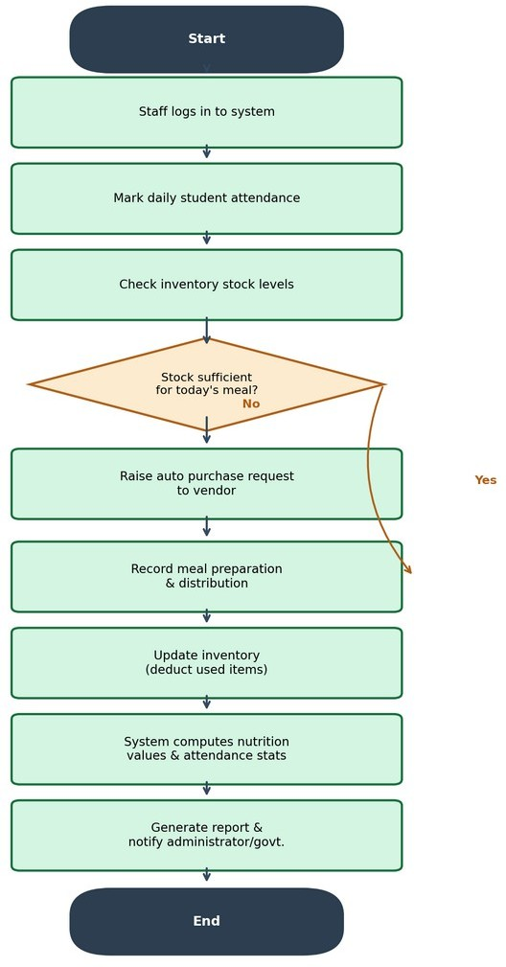

Key Performance Indicators (KPIs) & Metrics
Defines how success will be quantitatively measured post-deployment.
- Meal Record Accuracy Rate: Reach $\ge 98\%$ correlation between daily attendance logs and meal distribution records.
- Stock Inventory Variance: Reduce unaccounted ingredient leakage/loss to $< 2\%$.
- Alert Lead Time: Trigger low-stock warnings at least 3 days before critical stockouts occur.
- System Uptime: Maintain $\ge 99.5\%$ uptime during critical school operational hours ($7:00\text{ AM} - 4:00\text{ PM}$).

5. Non-Functional Testing Strategy
Expanded testing matrix beyond functional testing.
- Performance & Load Testing: Simulate concurrent meal logging from $1,000+$ schools simultaneously using tools like Apache JMeter to ensure response time remains $< 1.5\text{ seconds}$.
- Usability & Accessibility Testing: Conduct field tests with non-technical kitchen staff to ensure meal submission can be completed within 3 taps on a mobile screen.
- Security & Vulnerability Scans: Perform regular penetration testing and OWASP compliance checks to secure sensitive student attendance data.

6. Sustainable Development Goal 3 (SDG 3) Alignment Analysis
Connects software features directly to specific international health targets.
- Target 3.2 (End preventable deaths of newborns and children under 5): Ensures daily micronutrient and caloric intake compliance for early grade students.
- Target 3.d (Strengthen early warning systems for global health risks): Identifies regional malnutrition patterns early through aggregated district health outcome reports.

Epic 3: SDG 3 Nutrition Analysis & Reporting
- User Story 3.1: As a District Nutrition Officer, I want to generate monthly student nutrition and health outcome reports, so that I can evaluate compliance with SDG 3 standards across schools.
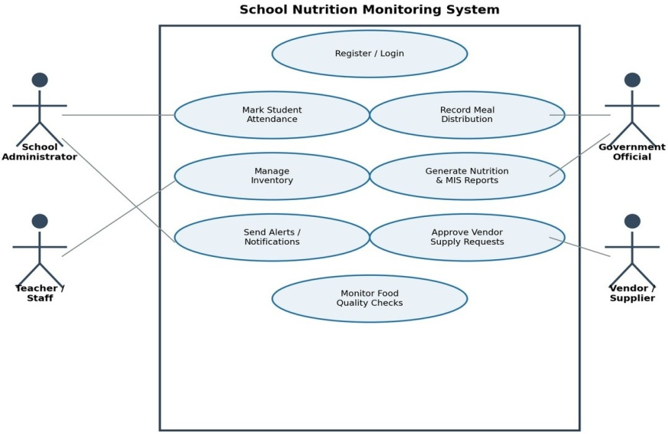
6. Acceptance Criteria (Given–When–Then Format)
User Story 1.1: Recording Meal Distribution
GIVEN the Kitchen Staff is logged into the mobile/web interface,
WHEN they input the count of meals distributed for a specific class and press submit,
THEN the system updates the daily meal record, updates database stock levels, and displays a confirmation message with a precise timestamp.

User Story 2.2: Automated Low-Stock Alert
GIVEN an inventory item's stock falls below its predefined threshold value,
WHEN the kitchen staff logs ingredient usage after meal preparation,
THEN the system automatically triggers and sends a low-stock alert notification to the School Administrator dashboard.

User Story 3.1: Generating Monthly SDG 3 Reports
GIVEN the District Nutrition Officer selects a school and target date range,
WHEN they click the 'Generate SDG 3 Report' button,
THEN the system aggregates attendance, meal quantity, and calorie metrics into a downloadable PDF/Excel compliance report.

7. Product Backlog Prioritization
Backlog ID | Feature / Epic Reference | Priority | Dependency | Business Value & Technical Rationale
PB-01 | Daily Meal & Attendance Logging | Must Have | None | Core operational entry point; foundational to all tracking.
PB-02 | Inventory & Stock Log Entry | Must Have | PB-01 | Essential to calculate raw ingredient consumption.
PB-03 | Low-Stock Alerts & Notifications | Should Have | PB-02 | Prevents stockouts and supply disruptions.
PB-04 | Monthly SDG 3 Nutrition Reporting | Should Have | PB-01, PB-02 | Required for district compliance and health audits.
PB-05 | Parent/Student Nutrition Portal | Could Have | PB-04 | Added value feature for public health transparency.

8. Sprint Planning & Sprint Backlog (Sprint 1)
Sprint Goal: Deliver a functional Minimum Viable Product (MVP) enabling kitchen staff to log daily meal counts, track core inventory usage, and trigger low-stock alerts.
Story ID | User Story Summary | Points | Technical Task Breakdown | Assigned Role
US-1.1 | Record meal distribution and attendance | 5 | 1. Implement meal entry form UI.  2. Develop API POST endpoint /api/v1/meals.  3. Connect DB schema for student logs. | Frontend Dev /  Backend Dev
US-2.1 | Update ingredient stock levels | 3 | 1. Build stock ledger UI view.  2. Write subtraction formula logic based on daily meal counts. | Backend Dev
US-2.2 | Low-stock notification triggers | 3 | 1. Develop threshold monitoring background service.  2. Build notification banner on Admin Dashboard. | Fullstack Dev

9. Story Point Estimation & Justification
Effort is estimated using Planning Poker based on the Fibonacci Sequence (1, 2, 3, 5, 8, 13):
- US-1.1 (5 Story Points): High complexity. Involves real-time input validation, backend aggregation with student attendance records, and database state updates.
- US-2.1 (3 Story Points): Moderate complexity. Requires standard CRUD operations for updating stock tables and simple mathematical deduction logic.
- US-2.2 (3 Story Points): Moderate complexity. Requires establishing automated event listeners or scheduled jobs to trigger UI alerts when thresholds breach.
10. System Architecture & System Flowchart
10.1 High-Level System Architecture
[ Mobile App (Cook) ] [ Admin Web App ] [ Officer Analytics ]
│ │ │
└────────────────────────┼────────────────────────┘
▼
[ REST API Gateway / HTTPS ]
│
┌───────────────────────┼───────────────────────┐
▼ ▼ ▼
[ Attendance Module ] [ Inventory Module ] [ Reporting Module ]
│ │ │
└───────────────────────┼───────────────────────┘
▼
[ Database / PostgreSQL ]

10.2 Operational System Flowchart
[ Start: Daily Meal Operation ]
│
▼
[ Login User Credentials ]
│
▼
[ Input Daily Meal Count ] ──► [ Query Class Attendance ]
│ │
▼ ▼
[ Deduct Stock Quantities ] ◄── [ Verify Discrepancies ]
│
▼
{ Low Stock Threshold? }
├── Yes ──► [ Trigger Notification to Admin Dashboard ]
└── No ──► [ Commit Log to Central Database ]
│
▼
[ Generate SDG 3 Daily Summary ]
│
▼
[ End ]

11. Use Case Diagram & Specification
+---------------------------------------------------------------+
| SCHOOL NUTRITION MONITORING SYSTEM |
| |
| (Log In) <----------------------------------------------+ |
| ^ | |
| | | |
| (Record Meal Distribution) <--- [ Kitchen Staff ] | |
| ^ | |
| | | |
| (Update Stock Quantity) <------ [ Kitchen Staff ] | |
| ^ | |
| | | |
| (Approve Orders & View Alerts) <- [ Admin / Headmaster ] | |
| ^ | |
| | | |
| (Generate SDG 3 Reports) <------- [ Nutrition Officer ] | |
+---------------------------------------------------------------+

12. Database Schema Design
Table 1: users
Column Name | Data Type | Constraints | Description
user_id | INT (PK) | Primary Key, Auto Increment | Unique user identity
username | VARCHAR(50) | NOT NULL, Unique | System account name
role | VARCHAR(20) | NOT NULL | Admin / Kitchen Staff / Officer
school_id | INT (FK) | Foreign Key | Associated school unit

Table 2: inventory_stock
Column Name | Data Type | Constraints | Description
item_id | INT (PK) | Primary Key | Unique ingredient ID
item_name | VARCHAR(100) | NOT NULL | Ingredient name (e.g., Rice, Pulses)
quantity_kg | DECIMAL(10,2) | DEFAULT 0.00 | Current stock level
threshold_kg | DECIMAL(10,2) | NOT NULL | Minimum safety stock limit

Table 3: meal_distribution_logs
Column Name | Data Type | Constraints | Description
log_id | INT (PK) | Primary Key | Unique meal record ID
school_id | INT (FK) | Foreign Key | Target school site
meals_served | INT | NOT NULL | Number of meals distributed
log_date | TIMESTAMP | DEFAULT NOW() | Time of meal distribution

13. Sprint Deliverables, Testing & Conclusion
13.1 Expected Sprint 1 Deliverables
- Meal Distribution Module: Fully functional web/mobile interface for kitchen staff to log daily meal counts accurately.
- Inventory Tracking Module: Automated ingredient deduction logic corresponding to recorded daily meals.
- Low-Stock Alert Subsystem: Real-time alert notifications rendered on the administrator dashboard.
- Relational Database Schema: Deployed production-ready database tables for User, Meal Log, Stock Item, and Daily Metrics.
13.2 Testing & Quality Assurance Strategy
- Unit Testing: Automated test suites validating ingredient subtraction logic and threshold calculations.
- Integration Testing: API endpoint testing connecting front-end meal entry with backend database updates.
- User Acceptance Testing (UAT): Field testing with school headmasters and kitchen personnel to verify workflow efficiency.
13.3 Conclusion
The proposed School Nutrition Monitoring System directly replaces error-prone manual paper operations with an efficient, transparent, and accurate digital platform. By applying Agile Sprint Planning, user stories, clear acceptance criteria, and structured software architecture, the solution ensures measurable compliance with UN Sustainable Development Goal 3 (Good Health and Well-Being).

